**DAILY ONLINE ACTIVITIES SUMMARY**

|  |  |  |  |  |  |  |  |  |
| --- | --- | --- | --- | --- | --- | --- | --- | --- |
| **Date:** | **31/05/2020** | | | | | **Name:** | **Lavanya D M** | |
| **Sem & Sec** | **4th & ‘A’** | | | | | **USN:** | **4al18cs041** | |
| **Online Test Summary** | | | | | | | | |
| **Subject** | | **Nil** | | | | | | |
| **Max. Marks** | | **Nil** | | **Score** | | | **Nil** | |
| **Certification Course Summary** | | | | | | | | |
| **Course** | **Pyton coursw** | | | | | | | |
| **Certificate Provider** | | | **Bitdegree** | | **Duration** | | | **1Week, 3hrs** |
| **Coding Challenges** | | | | | | | | |
| **Problem Statement: 1)**Java program to find the npr  **2)** Program to check Vowel or Consonant using Switch Case | | | | | | | | |
| **Status: complied** | | | | | | | | |
| **Uploaded the report in Github** | | | | | **yes** | | | |
| **If yes Repository name** | | | | | <https://github.com/lavanyamurthi/lockdown-coding/tree/master> | | | |
| **Uploaded the report in slack** | | | | | **yes** | | | |

Online Test Details: (Attach the snapshot and briefly write the report for the same)

NO TEST CONDUCTED ON SUNDAY 31/05/020

Certification Course Details: (Attach the snapshot and briefly write the report for the same)

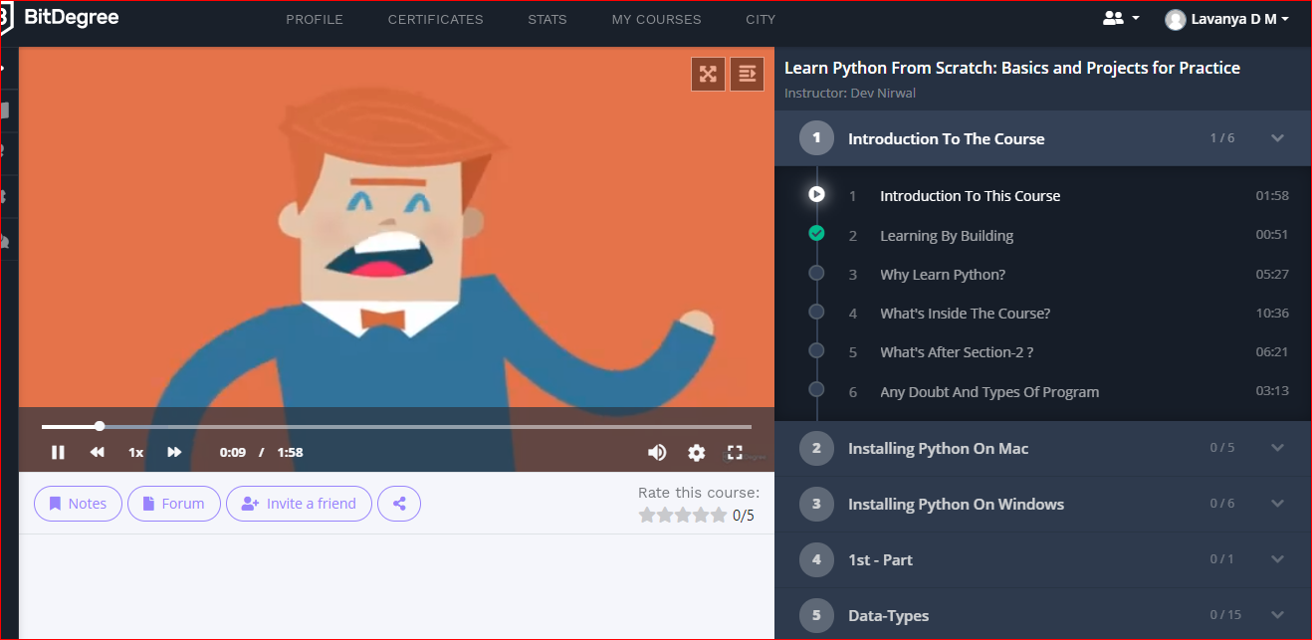

<https://github.com/lavanyamurthi/lockdown-certificate>

In this course I’m learning the python from the scratch from introduction to building

Coding Challenges Details: (Attach the snapshot and briefly write the report for the same)

Problem 1): **write the java program to find npr**

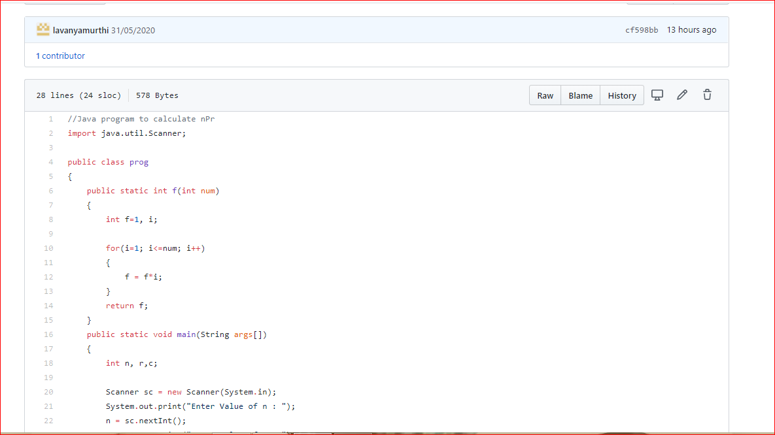

<https://github.com/lavanyamurthi/lockdown-coding/blob/master/npr.java>

**Program 2):** Java program to check Vowel or Consonant using Switch Case

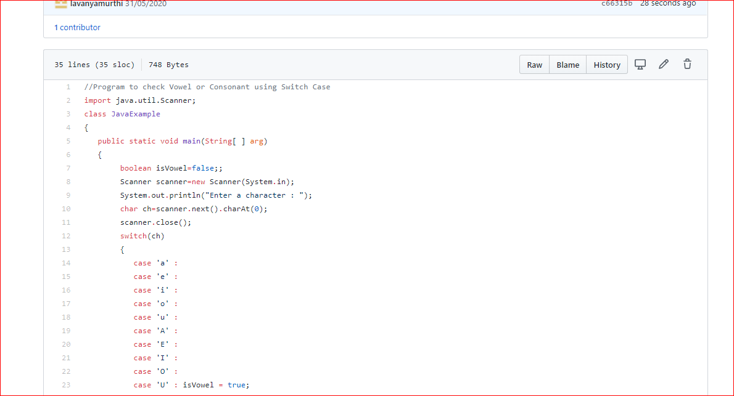

<https://github.com/lavanyamurthi/lockdown-coding/blob/master/vowel_consonant.java>